(Approx. 272 words)

Why You Need to Keep Your Browser Updated
By Kurt Jefferson, Editor, Central Kentucky Computer Society
https://ckcs.org/
lextown2 ** gmail.com

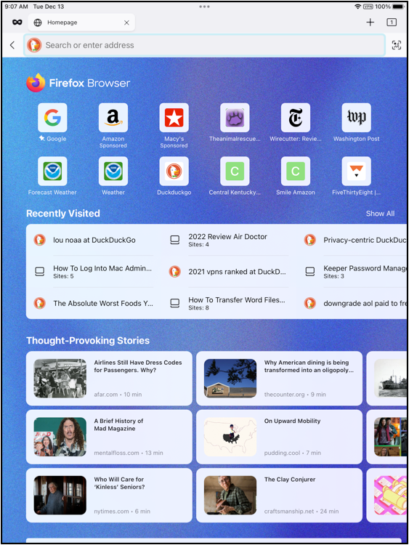
When was the last time you updated your web browser? If it’s been longer than a few weeks, you should check to see if an update is waiting to be installed.

Statista, the website that tracks browser usage, reports that:
• 73% of Microsoft Edge users
• 35% of Firefox users
• 23% of Safari users
in America and Western Europe are running outdated browsers.

A How-To-Geek article published in June 2021 explains why you need to use the latest version of your web browser:

Browser Updates Protect You

Browsers are continually updated for security reasons. However, outdated browsers contain opportunities for hackers to attempt to load malicious content onto your computer without your permission.

Updates patch these “openings” and block potential breaches so that the bad guys cannot install a large variety of viruses, malicious software, adware, and other crud on your machine.

If you visit an infected website, your outdated browser may not protect what’s sometimes called “drive-by downloads.”

These are incidents where malicious software automatically installs on your Mac, Windows, or Linux machine without you knowing about it.

How-To-Geek explains how to update Chrome, Firefox, Safari, and Edge on desktop machines and how to update your mobile browsers on iOS and Android devices.

If you’re unsure if your web browser is update-to-date, you can visit WhatIsMyBrowser? to find out. That website also provides plenty of other details about your web browser, including whether cookies are enabled, JavaScript is enabled, and other details such as your local IP address and Internet Service Provider.

